## Image result for ksu logo

King Saud University

College of Computer and Information Sciences

Information Technology Department

*IT210  
Fundamentals of IT*

TOY GAME

# ROLES AND RESPONSIBILITIES:

|  |  |  |  |
| --- | --- | --- | --- |
| Student name | Role | Reviewed section | Correction made |
| Nahla Aljeraisy | Group leader: Worked on interview 4  Worked on empathy post.  Worked on needs on the define stage as well as stages 3, 4, and 5, In addition to alien’s game. | Reviewed interview 2, define stage, and stage 3. | Grammar / Spilling |
| Reema Alangari | Worked on interview 1.  Worked on empathy map, Mr. Potato’s and woody game. | Reviewed insights, interview 3 and stage 5 | Grammar. |
| Aljawharah Bin Turaiky | Worked on interview 2. Worked on insights, elssie and woody game. | Reviewed empathy map, interview 1 and stage 4 | Grammar. |
| Basma Alamoud | Worked on interview 3.  Worked on problem statement, buzz game, and presentation. | Reviewed empathy post and the games. |  |

# 

# Introduction

Shortly, the main aim for our project is to teach children under 6 years old health and fitness through making different teaching techniques in the form of interesting games using scratch.

This report has several parts starting with interviews with targeted people. Moving through the five stages of design thinking. First, we started with stage 1 in which we made interviews and analyzed all the information summarized in the empathy post. In addition to the empathy map which includes ( says, thinks, does, and feels ) of the child. After that, we’ve written the needs, insights as well as the problem statement.

Then, we gathered all our ideas from brainstorming. Furthermore, we added some pictures of how the final game will look so we can have a clear view of how children will interact with the game. Finally, the report ends with the test stage in which we’ve written what worked and what doesn’t.

# 

# DESIGN THINKING STAGES:

# Stage1: Empathize

## 1.1 Interviews:

## Intreview1**:**

* Khalid salman: preschool child

Q1: What do you eat for breakfast?

A1: Usually I eat Labneh or chocolate sandwiches and drink milk.

Q2: What do you usually like to play ?

A2: I like to play with clay and playing Scooter with my brother.

Q3: How much time do you play on your iPad?

A3: Maximum four hours daily, but I divide the time twice. Two hours in the morning and two hours at night.

Q4- When do you go to bed?

A4: During the weekday I sleep at 8pm, but on the weekend at 12am.

Q5: Why do you find playing games on iPad interesting?

A5: Because it is more interactive and there’s a lot of different types of games that I can download, so I don’t feel bored.

## Intreview2:

* Maha Mohmmead : a mother of two children under 6 years

Q1: How does she communicate?

A1: At this age, she is attracted to new actions, for example, playing with toys that are full of colors. Also, she imitates mothers' behavior such as saying no when someone asks her to do something (because she heard me saying No).

Q2: How to teach your baby a new attitude?

A2: It's not easy to teach her a new habit that she does not like or hasn’t done before, for examples, not to throw the food if she doesn't like it, does not interrupt the eldest person and to show respect for her parents but I could manage it with a few punishments. As you know, no one likes punishment.

Q3: What is the problem that you are facing during the mealtime and why?

A3: The biggest problem is the mealtime because she doesn’t like to eat healthy food. so, I like to serve her food in different types of dishes like she loves Mickey Mouse, so I give her the food in plates that have Mickey Mouse. Sometimes change it to other characters because this will attract her then she eats.

Q4: How are you managing your baby's day?

A4: Actually, to manage her day I need to divide the daily activities to improve her mental and physical behavior. No doubt about that, my baby likes to do many activities like cycling, drawing and playing puzzles but the best time during the day is when she uses an iPad. However, I have trouble choosing a suitable play for her as you know she is not old enough to play any games. Also, I take her to an activities place like The Learning Zone and it's good because there are a lot of kids so I can play with them, and sometimes I give her new things to try. She helps me when I do my work, and this helps her to burn her energy.

Q5: why protect your baby from others while playing on the internet?

A5: because I think playing trendy games on the internet teaches her a bad attitude, but I would rather play with her in order to save her behavior and supervise her. It is important to protect her from these games because it has a big effect on their life.

## Intreview3:

* Sultan Fahad: Kindergarten child.

Q1: What do you eat for breakfast?

A1: Sometimes I eat pancakes with nutella and berries, and other times I just eat my candies and sweets because they are super yummy.

Q2: What do you usually like to play?

A2: I like playing on my iPad because there are so many games. That is not like boring physical games.

Q3: How much time do you play on your iPad?

A3: Most of my time. I start once I wake up in the morning until I go to bed.

Q4: When do you go to bed?

A4: I sleep at 12AM and I wake up at 11am.

Q5: Why do you find playing games on iPad interesting?

A5: Because I have an endless number of games I can play with, and I get attracted to interactive games and competitive ones. Additionally, all I want is on one device so I don't have to move or buy games from a game shop.

## Intreview4:

* Sara Mohammad: pediatric nutrition specialist.

Q1: How can poor nutrition affect children?

A1: Research shows that improper nutrition will cause tooth decay, obesity, underweight, less energy and it will decrease their interest in learning which will affect their development and academic performance as well as their mood and behavior.

Q2: What are the bad habits common among children?

A2: Not drinking enough water, screen time addiction, and not staying up late. In addition, many children eat their meals in front of television or other devices which make them eat more without feeling full, nor sleeping well which make them dizzy and hungry.

Q3: Why is healthy food not attractive to children?

A3: Because usually it’s served without figurative designs that makes it appealing to the children. So parents are supposed to consider the shape, visual appearance, and size of food. Furthermore, teaching them what they should do and eat and telling them why it’s important.

Q4: How can we have alternatives for junk food?

A4: There are several options in regards to that. For instance, replace chocolate with dark chocolate. Also change ice cream to frozen yogurt and chips with sweet potatoes, and most important, replace sweets with dried fruits.

Q5: What are the best ways to educate children about what is good and what is bad for their health?

A5: First tell them orally, then show them how to do it, after that make them apply it. Therefore, they will use their senses. If nothing worked, tell them what would happen if they did bad habits.

Q6: Anything you would like to add?

A6: Children’s education is very important, either from their families or from environmental factors like games. Educate children about healthy dishes, and active games. instruct them to clean their hands and brush their teeth. Make them practice hobbies they like.

## 1.2 Empathy Post:

Based on the previous interviews, we have gathered the following:

-Children are attracted to games full of colors.

-Healthy food is preferably served in attractive dishes in order to motivate children to eat.

-Educating games are supposed to be exciting, fun, and interactive.

-What children find visually appealing is very different from their parents.

-Use competition as a motivator for good eating and exercising habits.

-It’s difficult to get a child to do practice habits when they haven't had it ingrained in their minds or subconscious brains from an early age.

## 1.3 Empathy Map:

**THINKS:**

It's not easy to learn new habits.

It’s difficult to resist sweets and junk food.

Educational games are boring and not as interesting as trendy games.

Food is more enjoyable while watching TV.

**FEEL:**

They are afraid, worried, and scared.

**DOES:**

Eat my food in different types of

dishes.

Helping with the housework.

Play trendy games and watch TV.

**SAY:**

“I don’t like to eat healthy food.”

“I like playing on my iPad because there are so many games. That is not like boring physical games. “

“I eat pancakes with nutella and berries.”

“I sleep at 12AM and I wake up at 11am”

# 

# Stage2: Define

## 2.1 Capture Findings

### 2.1.1 Needs

* Application that is suitable, easy and clear for children under 6 years old.
* Make the learning process educational yet entertaining.
* An attractive, creative and distinctive application that is interactive and full of colors as well as having some sounds or background music.
* Competitive games for good eating and exercising habits.

### 2.1.2 Insights

* Teaches about the human body that will expand their knowledge.
* Playing active games with other children by encouraging them to have a healthier physical body.
* Games that help the child to use his senses and keeps him engaged visually, orally and even intellectually.
* Developing thinking skills and decision making.

## 2.2 Problem statement

Preschool children need to be motivated to learn about senses, as well as eating and exercising habits, because they are affected by the external environment and most games are no longer as educational as they are entertaining. Therefore, verbal gaudiness may be not sufficient alone and they need visual assistance like body language and simplified signs.

# Stage3: Ideate

### -Include colors and make a creative attracting theme.

-Record our voices to make the game interesting.

-Change the clothes of the character to make them suitable for the place and time.

-Can pause and resume the game anytime.

-Can play the game online with friends or family.

-Add score and ranking.

-Make the game story-like.

# Stage4: Prototype

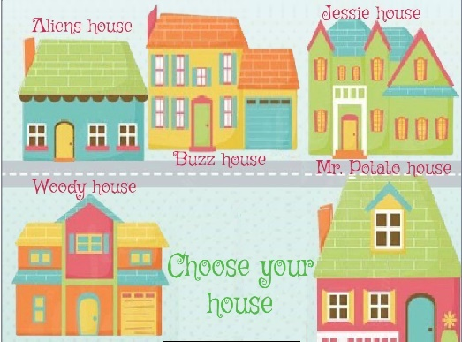

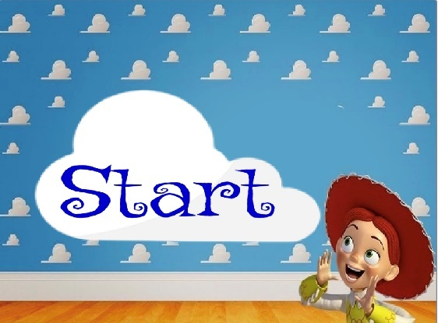

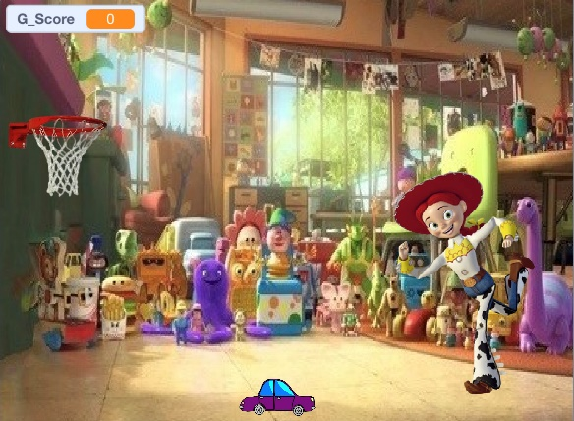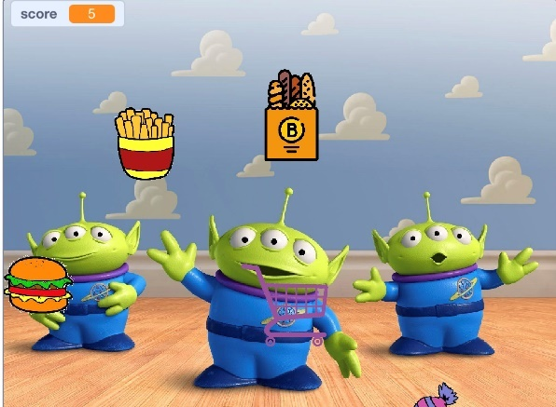

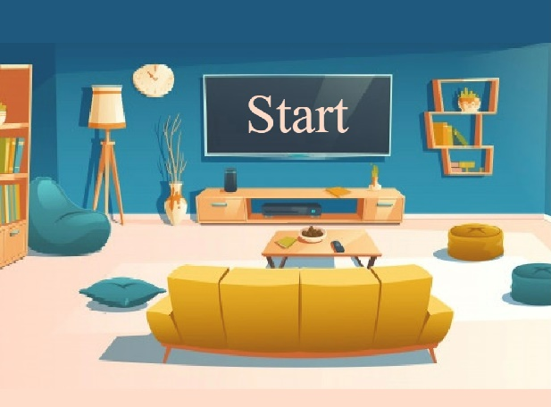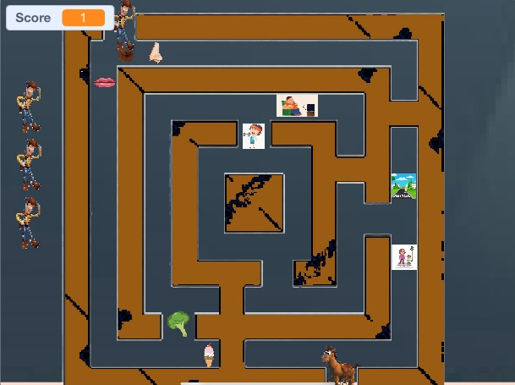

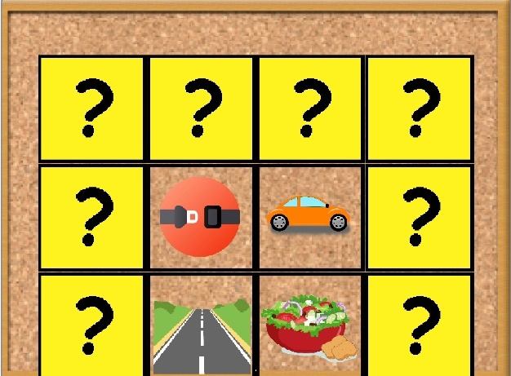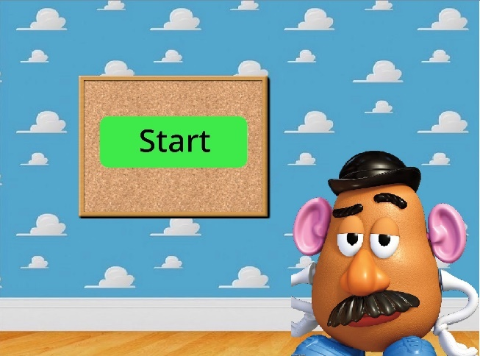

# Stage5: Test

Feedback Grid:

The game was tested by 2 children under 6 years old, and a mom.

|  |  |
| --- | --- |
| **What Worked?**  -Enjoyable learning.  -Teaching the child health and fitness through making different teaching techniques in the form of interesting games.  -Sounds and an attractive theme. | **What could be proved?**  -Adding levels and stages  -Adding more games  -make it an online game.  -improve the resolution of pictures.  -Adding quizzes to check their understanding.  -Add more languages. |
| **Questions?**  -Did it work smoothly and was it understood by the child easily?  -Will the game be suitable for children greater than 6 years old?  -Is the theme suitable and likable by all children? | **Ideas?**  -Add variety of exercises.  -Add versions suitable for different ages.  -Improving the game.  -Can pause and resume the game anytime.  -Add multi-playing option. |